
Python | Libraries | Jupyter
Hotel
Booking Application
EDA project
- Shubham Prasad Kuiri
Tools Used:

A Hotel Reservation & Management System
A Hotel Reservation & Management System
Initial Tasks:
Task 1: Data Cleaning: Handling missing values, correcting data types, and removing duplicates.

Ans: Objective:
The objective of data cleaning was to improve the quality and reliability of the dataset before performing exploratory data analysis. This involved handling missing values, correcting data types, and removing duplicate records to ensure accurate and consistent results.

- Dataset Before Cleaning: The dataset initially contained 119,390 records and 32 features. Before analysis, it was necessary to inspect the dataset for missing values, incorrect data types, and duplicate records.

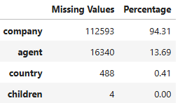
- Handling Missing Values: First, finding the only columns with missing values and also calculating their missing percentage.
missing_df = pd.DataFrame({
'Missing Values': df.isnull().sum(),
'Percentage':
round((df.isnull().sum()/len(df))*100,2)
})
missing_df[missing_df['Missing Values'] > 0].sort_values(by='Percentage', ascending=False)

Now, imputing the missing values with suitable statistical measures.

# Missing values were replaced with 0 because they represent bookings made without a company. Since company IDs are categorical identifiers, using mean, median, or mode would be inappropriate.
df['company'] = df['company'].fillna(0)

# Missing values were replaced with 0 to indicate bookings made without a travel agent (direct bookings). Agent IDs are categorical, so statistical imputation methods are not suitable.
df['agent'] = df['agent'].fillna(0)

# Missing values were filled with the mode since only a small number of records were missing, preserving the overall distribution of the data.
df['country'] = df['country'].fillna(df['country'].mode()[0])

# Missing values were filled with the median because the variable is numerical and skewed, making the median more robust to outliers than the mean.
df['children'] = df['children'].fillna(df['children'].median())

- Removing Duplicates: Duplicate records were removed to eliminate redundant information that could bias the analysis and produce inaccurate statistics, trends, and visualizations.

# Checking duplicates
df.duplicated().sum() np.int64(32013)

# Remove duplicate records
df = df.drop_duplicates() shape = (87377, 36)

- Correcting Data Types:
Step 1: Inspected the data types of all columns using df.info() to identify incorrectly assigned data types.
Step 2: Identified that the reservation_status_date column was stored as an object instead of a datetime data type.
Step 3: Converted the reservation_status_date column to the datetime format using pd.to_datetime() to enable accurate date-based analysis and time series operations.
df['reservation_status_date'] = pd.to_datetime(
df['reservation_status_date'],
format='mixed' )

Task 2: Descriptive Statistics: Generating summary statistics for numerical and categorical variables.

Ans: Objective: Descriptive statistics were generated to summarize the key characteristics of the cleaned dataset. This task provides an overview of the distribution, central tendency, and variability of numerical variables, along with the frequency distribution of categorical variables, helping to understand the data before performing further analysis.
- Numerical Descriptive Statistics: df.describe().T
Key Observations:
- The cleaned dataset contains 87,377 unique booking records after removing duplicate entries.
- Approximately 27.5% of the bookings were canceled, while the remaining bookings were successfully completed.
- The average booking lead time is 80 days, with some bookings made up to 737 days in advance.
- Most bookings consist of 2 adults with no children or babies, indicating that couples are the dominant customer group.
- Guests typically stay for 2–3 weeknights and 1 weekend night, suggesting relatively short-duration stays.
- The average Average Daily Rate (ADR) is approximately 106.35, although the presence of negative and extremely high ADR values indicates potential outliers that require further investigation.
- The median value for days in waiting list is 0, indicating that most bookings were confirmed immediately without waiting.
- The majority of customers are new guests, as repeated guests account for only a small proportion of total bookings.
- Most bookings required no car parking spaces and had few or no special requests, indicating standard booking preferences.
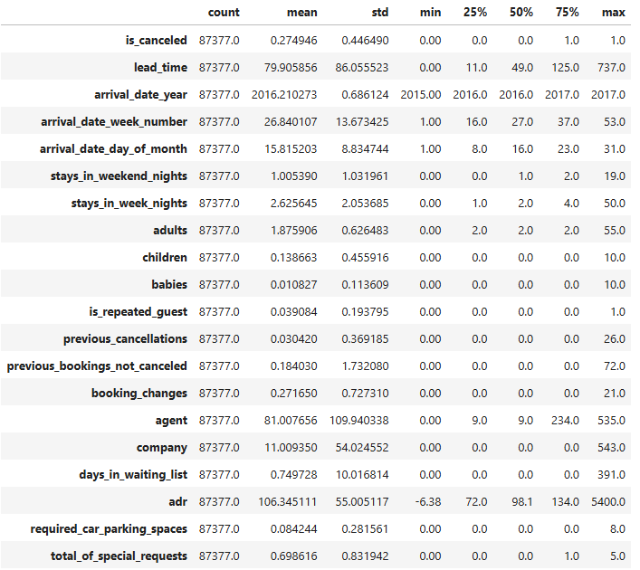

- Categorical Descriptive Statistics: df.describe(include='object').T
Key Observations:
- The dataset contains bookings from 2 hotel types, with City Hotel accounting for the majority of bookings.
- Bookings are distributed across all 12 months, with August recording the highest number of reservations.
- Bed & Breakfast (BB) is the most preferred meal plan among guests.
- Guests belong to 177 different countries, with Portugal (PRT) contributing the highest number of bookings.
- Online Travel Agencies (Online TA) are the dominant market segment, indicating that online platforms are the primary source of bookings.
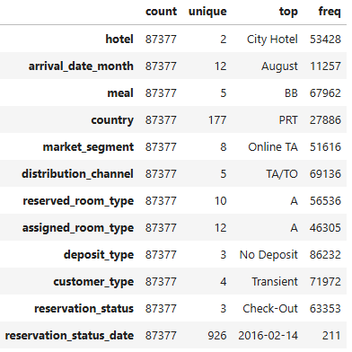
- The TA/TO (Travel Agents/Tour Operators) distribution channel is the most frequently used booking channel.
- Room Type A is the most commonly reserved as well as assigned room type, indicating high demand for this room category.
- The vast majority of bookings are made with No Deposit, suggesting that customers generally prefer flexible booking options.
- Transient customers form the largest customer segment, indicating that most bookings are made by individual travelers rather than groups or contract customers.
- Most reservations have a Check-Out status, meaning the majority of bookings were successfully completed.

Task 3: Data Visualization: Creating visualizations to understand the distribution of variables and relationships between them.

Ans: Objective:
The objective of this task was to visually explore the distribution of key variables and identify meaningful patterns, trends, and relationships within the hotel booking dataset. Data visualizations provide an intuitive understanding of customer behavior, booking characteristics, and operational performance, supporting data-driven decision-making.

Approach:
Various visualization techniques such as bar charts, histograms, box plots, and count plots were used to examine the distribution of categorical and numerical variables. The visualizations were designed to identify customer preferences, booking patterns, cancellation behaviour, and pricing trends.

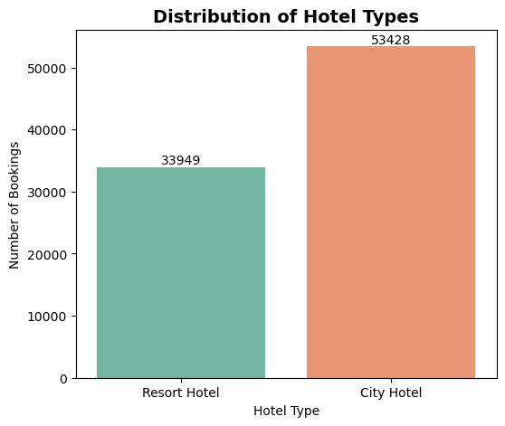
- Distribution of Hotel Types:

plt.figure(figsize=(6,5))
ax = sns.countplot(
data=df,
x='hotel',
palette='Set2'
)
for container in ax.containers:
ax.bar_label(container)
plt.title('Distribution of Hotel Types', fontsize=14, fontweight='bold')
plt.xlabel('Hotel Type')
plt.ylabel('Number of Bookings')
plt.show()

- Booking Cancellation Distribution:

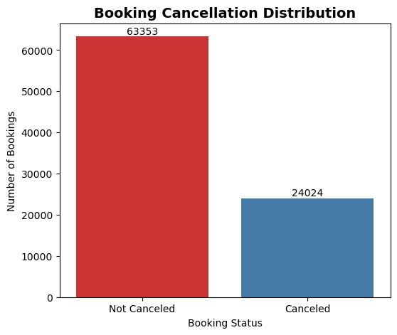
plt.figure(figsize=(6,5))
ax = sns.countplot(
data=df,
x='is_canceled',
palette='Set1'
)
ax.set_xticklabels(['Not Canceled', 'Canceled'])
for container in ax.containers:
ax.bar_label(container)
plt.title('Booking Cancellation Distribution', fontsize=14, fontweight='bold')
plt.xlabel('Booking Status')
plt.ylabel('Number of Bookings')
plt.show()

- Monthly Booking Distribution:

plt.figure(figsize=(12,5))
ax = sns.countplot(
data=df,
x='arrival_date_month',
order=month_order,
palette='crest'
)
for container in ax.containers:
ax.bar_label(container)
plt.title('Monthly Booking Distribution', fontsize=14, fontweight='bold')
plt.xlabel('Arrival Month')
plt.ylabel('Number of Bookings')
plt.xticks(rotation=45)
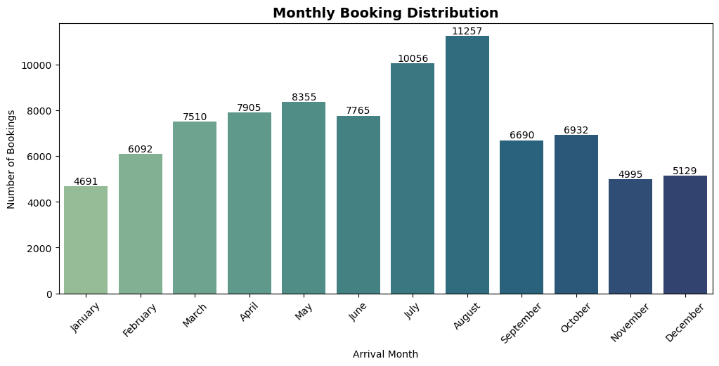
plt.show()

- Booking Distribution by Market Segment:

plt.figure(figsize=(10,6))
market_order = df['market_segment'].value_counts().index
ax = sns.countplot(
data=df,
y='market_segment',
order=market_order,
palette='crest'
)
for container in ax.containers:
ax.bar_label(container)
plt.title("Distribution of Bookings Across Market Segments", fontsize=14, fontweight='bold')
plt.xlabel('Number of Bookings')
plt.ylabel('Market Segment')
plt.show()
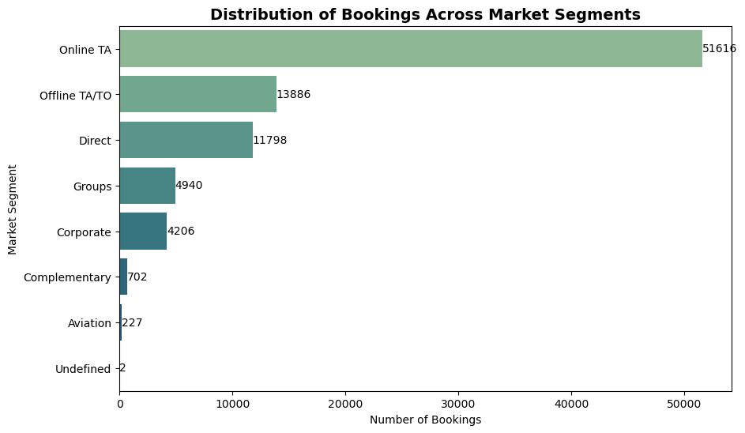

- Customer Type Distribution:

plt.figure(figsize=(8,5))
customer_order = df['customer_type'].value_counts().index
ax = sns.countplot(
data=df,
x='customer_type',
order=customer_order,
palette='Set2'
)
for container in ax.containers:
ax.bar_label(container)
plt.title('Distribution of Customer Types', fontsize=14, fontweight='bold')
plt.xlabel('Customer Type')
plt.ylabel('Number of Bookings')
plt.xticks(rotation=15)
plt.show()

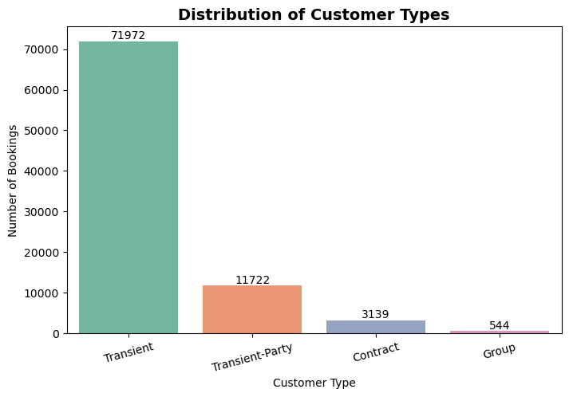

- Booking Cancellation by Hotel Type:

plt.figure(figsize=(7,5))
ax = sns.countplot(
data=df,
x='hotel',
hue='is_canceled',
palette='Set2'
)
handles, labels = ax.get_legend_handles_labels()
ax.legend(handles, ['Not Canceled', 'Canceled'], title='Booking Status')

for container in ax.containers:
ax.bar_label(container)

plt.title('Booking Cancellation by Hotel Type', fontsize=14, fontweight='bold')
plt.xlabel('Hotel Type')
plt.ylabel('Number of Bookings')

plt.show()

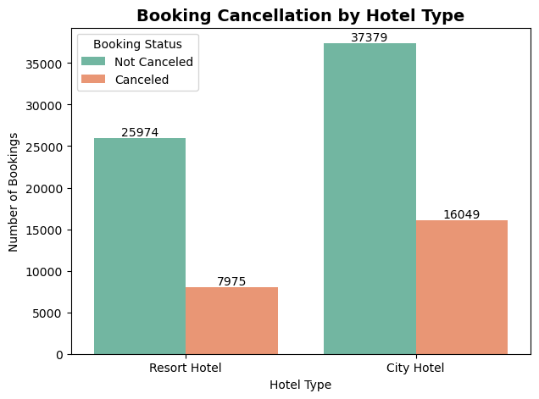
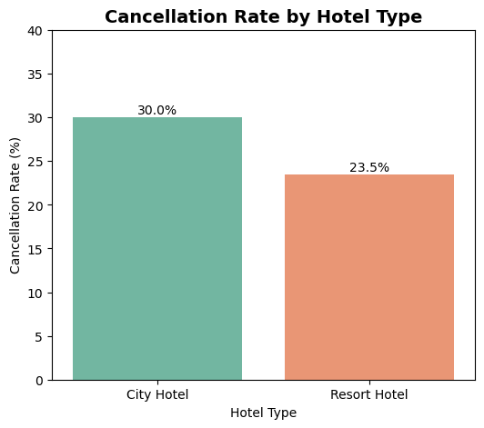
- Cancellation Rate by Hotel Type:
cancel_rate = (
df.groupby('hotel')['is_canceled']
.mean()
.mul(100)
.reset_index()
)
plt.figure(figsize=(6,5))
ax = sns.barplot(
data=cancel_rate,
x='hotel',
y='is_canceled',
palette='Set2'
)
for container in ax.containers:
ax.bar_label(container, fmt='%.1f%%')
plt.title('Cancellation Rate by Hotel Type', fontsize=14, fontweight='bold')
plt.xlabel('Hotel Type')
plt.ylabel('Cancellation Rate (%)')
plt.ylim(0, cancel_rate['is_canceled'].max()+10)
plt.show()

- ADR Distribution by Hotel Type:
plt.figure(figsize=(7,5))
ax = sns.boxplot(
data=df,
x='hotel',
y='adr',
palette='Set2'
)
plt.title('ADR Distribution by Hotel Type', fontsize=14, fontweight='bold')
plt.xlabel('Hotel Type')
plt.ylabel('Average Daily Rate (ADR)')

plt.show()plt.figure(figsize=(7,5))
ax = sns.boxplot(
data=df,
x='hotel',
y='adr',
palette='Set2'
)
plt.title('ADR Distribution by Hotel Type', fontsize=14, fontweight='bold')
plt.xlabel('Hotel Type')
plt.ylabel('Average Daily Rate (ADR)')
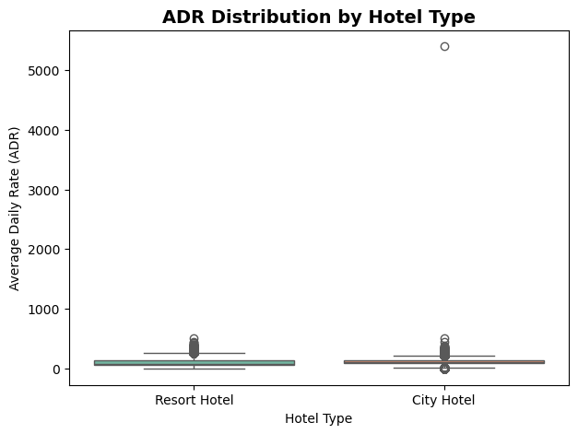
plt.show()

- Lead Time by Booking Status:

plt.figure(figsize=(8,5))

ax = sns.boxplot(
data=df,
x='is_canceled',
y='lead_time',
palette='Set2'
)

ax.set_xticklabels(['Not Canceled', 'Canceled'])

plt.title('Lead Time by Booking Status', fontsize=14, fontweight='bold')
plt.xlabel('Booking Status')
plt.ylabel('Lead Time (Days)')

plt.show()
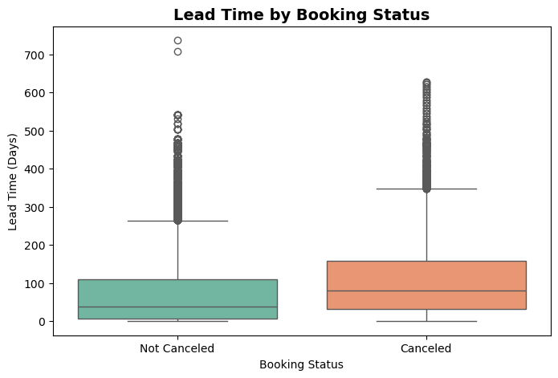

- Average ADR by Market Segment:

adr_segment = (
df.groupby('market_segment')['adr']
.mean()
.sort_values(ascending=False)
.reset_index()
)
plt.figure(figsize=(10,5))
ax = sns.barplot(
data=adr_segment,
x='market_segment',
y='adr',
palette='viridis'
)
for container in ax.containers:
ax.bar_label(container, fmt='%.2f')
plt.xticks(rotation=45)
plt.title("Average ADR by Market Segment")
plt.xlabel("Market Segment")
plt.ylabel("Average ADR")
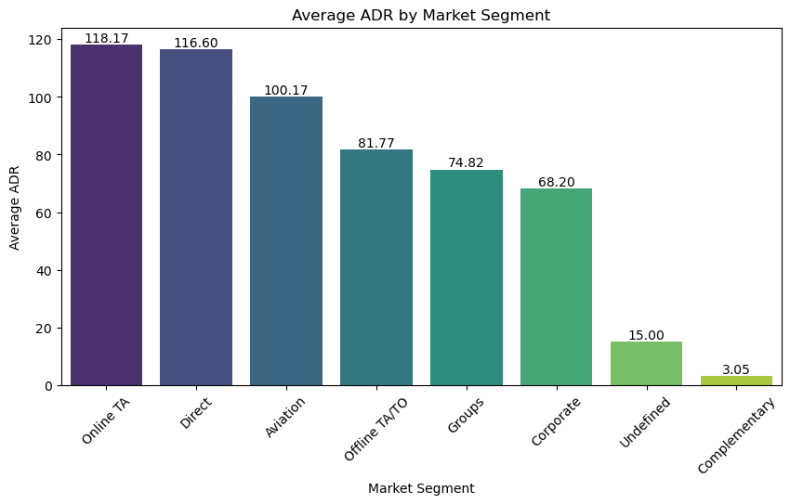
plt.show()

Summary:
The visualizations revealed important patterns in hotel booking behaviour. City Hotels received a higher volume of bookings than Resort Hotels, while most reservations were successfully completed rather than cancelled. Online Travel Agencies contributed the largest share of bookings, transient customers formed the dominant customer group, and ADR varied across hotel types and market segments. These visual insights provide a strong foundation for the subsequent time series, segmentation, and booking cancellation analyses.

Task 4: Time Series Analysis: Analysing trends and patterns over time.

Ans: Objective:
The objective of this task was to analyse booking trends and patterns over time. Time series analysis helps identify seasonal variations, cancellation trends, and changes in Average Daily Rate (ADR), enabling a better understanding of customer booking behaviour and hotel performance over different time periods.

Approach:
Line charts were used to visualize monthly booking trends, cancellation patterns, and ADR variations over time. These visualizations help identify seasonal demand, peak booking periods, and pricing fluctuations throughout the study period.

- Monthly Booking Trend: First creating a proper ‘arrival’ date column since the days, months and years are separately present in the given dataset. So in order to create a date column we combined all these date segments.

# Create a proper arrival date column
df['arrival_date'] = pd.to_datetime(
df['arrival_date_day_of_month'].astype(str) + ' ' +
df['arrival_date_month'] + ' ' +
df['arrival_date_year'].astype(str)
)

df[['arrival_date']].head()

monthly_bookings = (
df.groupby(df['arrival_date'].dt.to_period('M'))
.size()
.reset_index(name='Bookings')
)
monthly_bookings['arrival_date'] = monthly_bookings['arrival_date'].astype(str)
plt.figure(figsize=(12,5))
ax = sns.lineplot(
data=monthly_bookings,
x='arrival_date',
y='Bookings',
marker='o'
)
plt.title('Monthly Booking Trend', fontsize=14, fontweight='bold')
plt.xlabel('Month')
plt.ylabel('Number of Bookings'
plt.xticks(rotation=45)
plt.tight_layout()
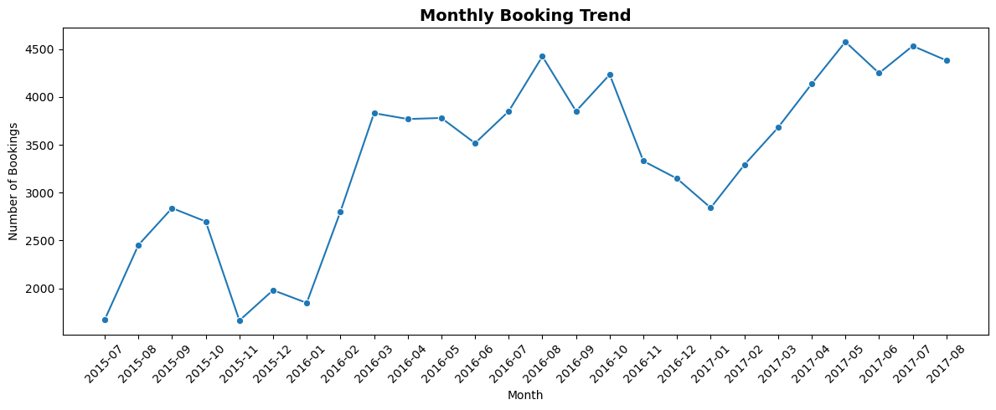
plt.show()

Key Observation:
- Hotel bookings exhibit a clear seasonal pattern across the observed period.
- Booking demand generally peaks during the summer months (July–October), with the highest number of bookings recorded around May–October 2017.
- The lowest booking volumes are observed during the winter months (November–January), indicating an off-season for hotel reservations.
- A recurring seasonal trend is visible across multiple years, suggesting that booking demand is influenced by holiday seasons and travel patterns.
- These trends can help hotel management optimize pricing strategies, staffing levels, and room inventory during peak and off-peak periods.

- Monthly Bookings vs Cancellations:

monthly_summary = (
df.groupby(df['arrival_date'].dt.to_period('M')).agg(
Total_Bookings=('hotel', 'count'),
Cancellations=('is_canceled', 'sum')
).reset_index()
)
monthly_summary['arrival_date'] = monthly_summary['arrival_date'].astype(str)
plt.figure(figsize=(12,6))
plt.plot(
monthly_summary['arrival_date'],
monthly_summary['Total_Bookings'],
marker='o',
linewidth=2,
label='Total Bookings'
)

plt.plot(
monthly_summary['arrival_date'],
monthly_summary['Cancellations'],
marker='o',
linewidth=2,
label='Cancellations'
)
plt.title('Monthly Bookings vs Cancellations', fontsize=14, fontweight='bold')
plt.xlabel('Month')
plt.ylabel('Number of Bookings')
plt.xticks(rotation=45)

plt.legend()
plt.grid(alpha=0.3)

plt.tight_layout()
plt.show()

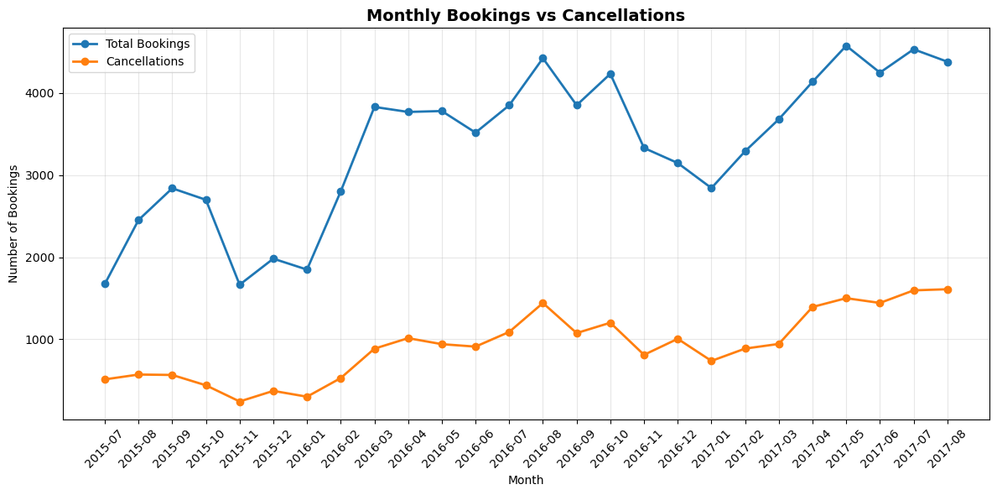
Key Observation:
- Monthly bookings and cancellations exhibit a similar trend over the observed period, indicating that higher booking volumes are generally accompanied by higher cancellation volumes.
- Booking demand shows a gradual upward trend from 2015 to 2017, with noticeable peaks during the middle of each year.
- Cancellations also increase during high-demand periods but remain significantly lower than the total number of bookings throughout the timeline.
- Temporary declines in both bookings and cancellations are observed around the end and beginning of each year, suggesting seasonal fluctuations in hotel demand.
- Despite fluctuations in cancellations, the gap between total bookings and cancellations remains substantial across all months, indicating consistent booking retention over the study period.

- Average Daily Rate (ADR) by Month:
monthly_rate = (
df.groupby(df['arrival_date'].dt.to_period('M'))
.agg(
Total_Bookings=('hotel', 'count'),
Cancellations=('is_canceled', 'sum')
)
.reset_index()
)

# Calculate cancellation rate
monthly_rate['Cancellation_Rate'] = (
monthly_rate['Cancellations'] /
monthly_rate['Total_Bookings']
) * 100

monthly_rate['arrival_date'] = monthly_rate['arrival_date'].astype(str)

plt.figure(figsize=(12,5))

plt.plot(
monthly_rate['arrival_date'],
monthly_rate['Cancellation_Rate'],
marker='o',
linewidth=2,
color='crimson'
)

plt.title('Monthly Cancellation Rate Trend', fontsize=14, fontweight='bold')
plt.xlabel('Month')
plt.ylabel('Cancellation Rate (%)')

plt.xticks(monthly_rate.index[::2],
monthly_rate['arrival_date'][::2],
rotation=45)

plt.grid(alpha=0.3)

plt.tight_layout()
plt.show()

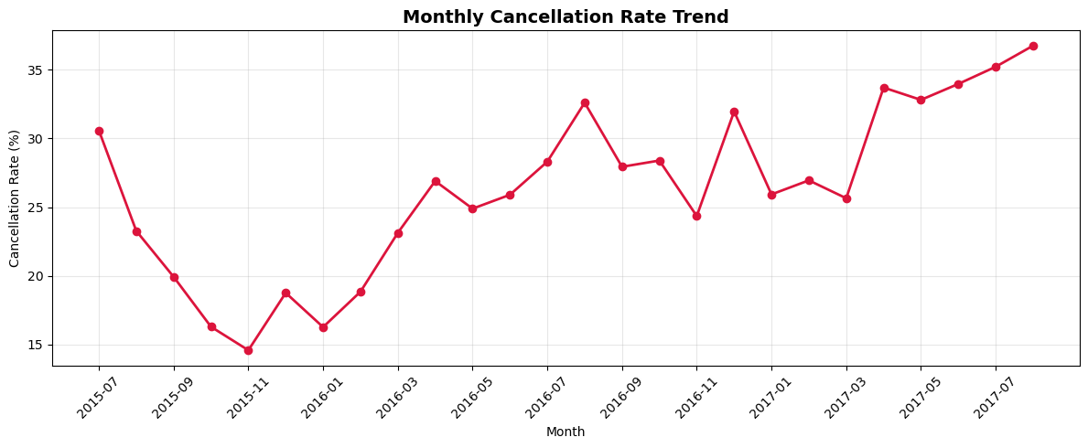

Key Observation:
- The monthly cancellation rate shows an overall increasing trend throughout the study period, rising from approximately 15–20% in late 2015 to around 35–37% by mid-2017.
- The lowest cancellation rate is observed around November 2015 (approximately 15%), while the highest rate occurs in August 2017 (approximately 37%).
- Although the cancellation rate fluctuates across months, it remains consistently above 25% during most of 2016 and continues to increase in 2017.
- The rising cancellation rate indicates that a growing proportion of bookings were being canceled over time, highlighting the need to investigate the underlying factors contributing to cancellations.
- Monitoring cancellation rates can help hotel management refine booking policies, pricing strategies, and customer retention initiatives to minimize revenue loss.

- Monthly Cancellation Rate Trend:

monthly_adr = (
df.groupby('arrival_date_month', observed=False)['adr']
.mean()
.reindex(month_order)
.reset_index()
)
plt.figure(figsize=(12,5))
ax = sns.barplot(
data=monthly_adr,
x='arrival_date_month',
y='adr',
palette='tab10'
)
for container in ax.containers:
ax.bar_label(container, fmt='%.1f')
plt.title('Average Daily Rate (ADR) by Month', fontsize=14, fontweight='bold')
plt.xlabel('Month')
plt.ylabel('Average ADR')
plt.xticks(rotation=45)
plt.tight_layout()

plt.show()
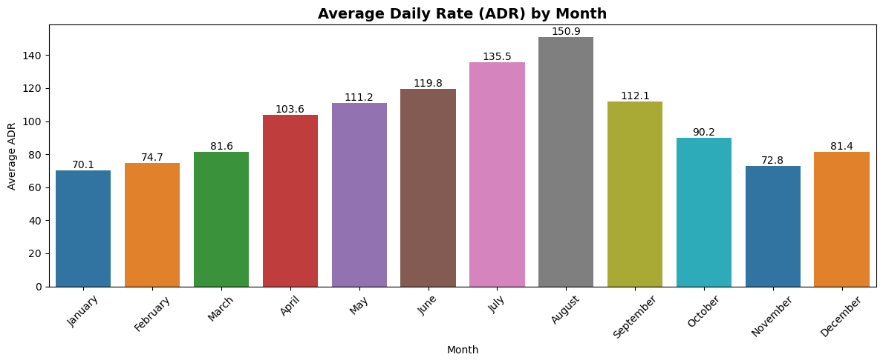

Key Observation:
- The Average Daily Rate (ADR) exhibits a clear seasonal pattern throughout the year.
- ADR steadily increases from January (70.1) and reaches its highest value in August (150.9), indicating peak room pricing during the high-demand travel season.
- After August, the average room rate declines gradually, dropping to around 72.8 in November before showing a slight recovery in December (81.4).
- The substantial variation in ADR across months suggests that the hotel adopts a seasonal pricing strategy, charging higher room rates during periods of increased demand and lowering prices during off-peak months.
- These insights can help hotel management optimize pricing policies, forecast revenue, and plan promotional campaigns during low-demand periods.

Summary of Time Series Analysis:
The time series analysis revealed clear temporal patterns in hotel bookings, cancellations, and room pricing. Booking volumes exhibited seasonal fluctuations with noticeable peak periods, while cancellation trends varied across different months. Additionally, the Average Daily Rate (ADR) increased during high-demand seasons, indicating the influence of seasonal demand on hotel pricing. These findings provide valuable insights for demand forecasting, pricing optimization, and operational planning.

Task 5: Segmentation Analysis: Identifying and analyzing different customer segments.

Ans: Objective:
The objective of this task was to identify and compare different customer segments based on hotel type, booking source, and customer category. Segmentation analysis helps understand how customer groups are distributed across hotel types, providing insights that support targeted marketing and customer relationship strategies.
Approach:
Comparative visualizations were created to examine the distribution of market segments and customer types across City Hotels and Resort Hotels. These analyses highlight the differences in customer composition and booking sources between the two hotel categories.

- Market Segment Distribution by Hotel Type:

# (100% Stacked Bar)
market_hotel = pd.crosstab( df['hotel'], df['market_segment']
,normalize='index'
) * 100
market_hotel.plot( kind='bar', stacked=True, figsize=(10,6),
colormap='tab20'
)
plt.title('Market Segment Distribution by Hotel Type (%)',
fontsize=14,
fontweight='bold')

plt.xlabel('Hotel Type')
plt.ylabel('Percentage of Bookings (%)')
plt.legend(
title='Market Segment',
bbox_to_anchor=(1.02,1),
loc='upper left'
)
plt.tight_layout()
plt.show()
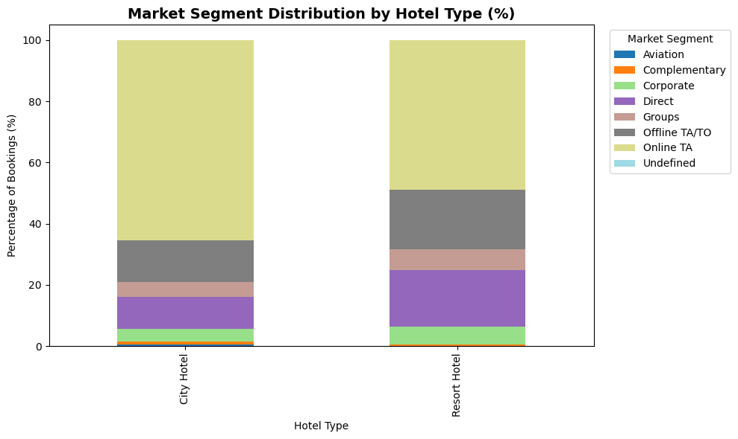

Key Observation:

- Online TA is the largest booking source for both City Hotels and Resort Hotels, accounting for nearly half of all bookings in each hotel type.
- Resort Hotels receive a noticeably higher proportion of Direct bookings than City Hotels, indicating that guests are more likely to book resort stays directly.
- City Hotels have a relatively higher share of Groups and Complementary bookings compared to Resort Hotels.
- The proportion of Offline TA/TO bookings is comparable across both hotel types, highlighting the continued importance of traditional travel agencies.
- The differences in booking source composition suggest that City Hotels and Resort Hotels attract customers through different acquisition channels, supporting the need for hotel-specific marketing and distribution strategies.

- Customer Type Distribution by Hotel Type:

plt.figure(figsize=(10,6))

ax = sns.countplot(
data=df,
x='customer_type',
hue='hotel',
palette='Set2'
)
for container in ax.containers:
ax.bar_label(container)

plt.title('Customer Type Distribution by Hotel Type', fontsize=14, fontweight='bold')
plt.xlabel('Customer Type')
plt.ylabel('Number of Bookings')
plt.legend(title='Hotel Type')

plt.tight_layout()

plt.show()
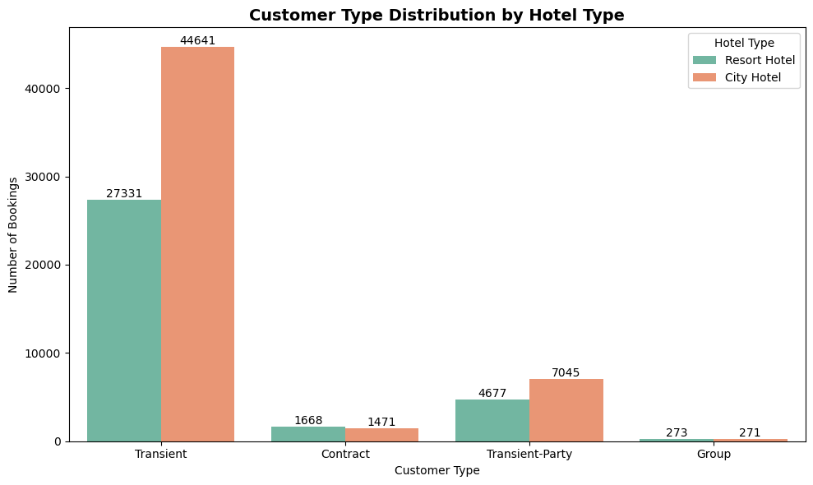
Key Observation:
- Transient customers represent the largest customer segment for both hotel types, with City Hotels (44,641 bookings) attracting considerably more transient guests than Resort Hotels (27,331 bookings).
- Transient-Party customers are the second-largest segment, with City Hotels receiving a higher number of bookings than Resort Hotels.
- Contract customers are slightly more concentrated in Resort Hotels, suggesting that resorts rely relatively more on long-term or contractual bookings.
- Group bookings are minimal for both hotel types, indicating that group reservations contribute only a small share of total bookings.
- Overall, City Hotels primarily cater to individual and transient travelers, whereas Resort Hotels exhibit a relatively more balanced customer mix with a higher proportion of contract bookings.

Summary of Segmentation Analysis:
The segmentation analysis revealed that the composition of customer segments varies between City Hotels and Resort Hotels. While both hotel types receive bookings from multiple market segments, their customer mix and booking sources differ, indicating the need for hotel-specific marketing and customer acquisition strategies. Understanding these differences enables hotels to better target their services and optimize business performance.
Task 6: Booking and Cancellation Analysis: Examining booking attributes and their impact on cancellations and ADR.

Ans: Objective:
The objective of this task was to examine how various booking attributes influence cancellation behaviour and Average Daily Rate (ADR). This analysis helps identify the key factors associated with booking cancellations, enabling hotels to improve booking management, optimize pricing strategies, and enhance overall operational efficiency.

Approach:
Comparative visualizations were created to analyse the impact of booking attributes such as hotel type, deposit type, distribution channel, booking modifications, and reservation status on booking cancellations and ADR. These analyses provide insights into customer booking behaviour and the factors affecting hotel revenue.

- Cancellation Rate by Deposit Type:
deposit_cancel = (
df.groupby("deposit_type")["is_canceled"] .mean().mul(100)
.sort_values(ascending=False)
)
colors = ["#e74c3c", "#3498db", "#2ecc71"]
plt.figure(figsize=(8,5))
ax = plt.bar(
deposit_cancel.index,
deposit_cancel.values,
color=colors[:len(deposit_cancel)]
)
# Data Labels
for bar in ax:
height = bar.get_height()
plt.text(bar.get_x() + bar.get_width()/2, height + 1, f"{height:.1f}%",ha="center",
fontsize=10
)
plt.title("Cancellation Rate by Deposit Type",fontsize=14, fontweight='bold')
plt.xlabel("Deposit Type")
plt.ylabel("Cancellation Rate (%)")
plt.grid(axis="y", linestyle="--", alpha=0.4)

plt.tight_layout()
plt.show()
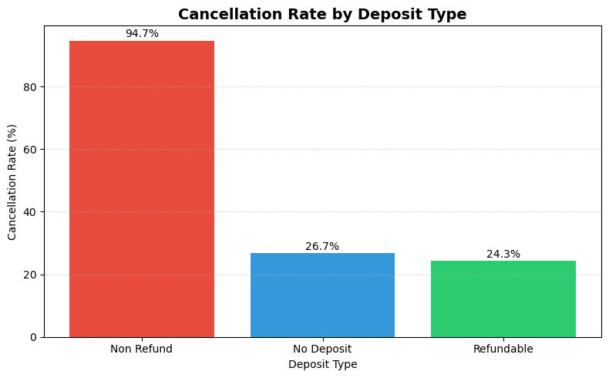
Key Observation:
- Non-Refund bookings have the highest cancellation rate (94.7%), indicating that most bookings under this policy were ultimately cancelled.
- No Deposit and Refundable bookings have significantly lower cancellation rates (26.7% and 24.3%, respectively).
- Despite requiring a non-refundable deposit, the non-refund category still experiences a very high cancellation rate, suggesting that guests often cancel even if they forfeit their deposit.
- Overall, deposit type has a strong influence on booking cancellation behaviour, making it an important factor when designing pricing and reservation policies.

- Cancellation Rate by Distribution Channel:
channel_cancel = (
df.groupby("distribution_channel")["is_canceled"].mean().mul(100)
.sort_values(ascending=False)
)
colors = plt.cm.Set2(range(len(channel_cancel)))
plt.figure(figsize=(9,5))
bars = plt.barh(
channel_cancel.index,
channel_cancel.values,
color=colors
)
# Data Labels
for bar in bars:
width = bar.get_width()
plt.text( width + 0.5, bar.get_y() + bar.get_height()/2, f"{width:.1f}%",
va="center",
fontsize=10
)

plt.title("Cancellation Rate by Distribution Channel",fontsize=14, fontweight='bold')
plt.xlabel("Cancellation Rate (%)")
plt.ylabel("Distribution Channel")
plt.grid(axis="x", linestyle="--", alpha=0.4)

plt.gca().invert_yaxis() # Highest at the top
plt.tight_layout()
plt.show()
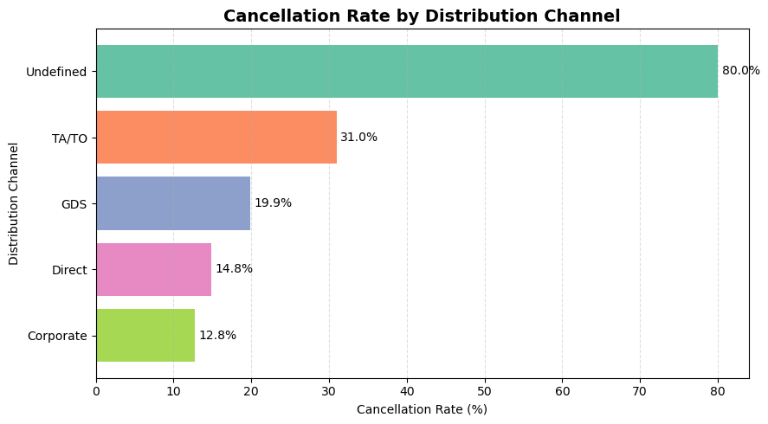

Key Observation:
- TA/TO has the highest cancellation rate (31.0%) among the major distribution channels, indicating a higher risk of booking cancellations.
- Corporate is the most reliable distribution channel, with the lowest cancellation rate (12.8%), followed closely by Direct bookings (14.8%).
- GDS shows a moderate cancellation rate (19.9%), falling between Direct and TA/TO channels.
- The Undefined channel records an 80.0% cancellation rate, but this category should be interpreted cautiously as it likely contains very few bookings or incomplete records.
- Overall, Direct and Corporate channels demonstrate better booking retention, while TA/TO bookings require stronger cancellation management strategies.

- Cancellation Rate by Hotel Type:
hotel_cancel = (
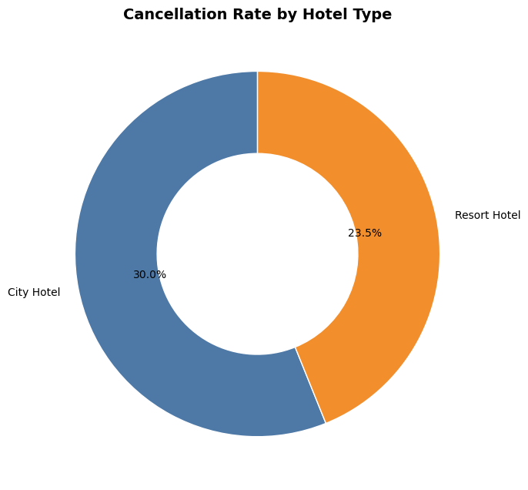
df.groupby("hotel")["is_canceled"]
.mean()
.mul(100)
)

colors = ["#4E79A7", "#F28E2B"]

plt.figure(figsize=(7,7))

wedges, texts, autotexts = plt.pie(
hotel_cancel,
labels=hotel_cancel.index,
autopct=lambda pct: f"{pct/100*hotel_cancel.sum():.1f}%",
startangle=90,
colors=colors,
wedgeprops=dict(width=0.45, edgecolor="white")
)

plt.title("Cancellation Rate by Hotel Type",fontsize=14, fontweight='bold')

plt.tight_layout()
plt.show()

Key Observation:
- City Hotels have a higher cancellation rate (30.0%) than Resort Hotels (23.5%).
- The higher cancellation rate in City Hotels suggests that urban bookings are generally more prone to changes or cancellations.
- Resort Hotels experience comparatively better booking retention, indicating more committed travel plans.
- The difference in cancellation rates highlights the need for hotel-specific cancellation and revenue management strategies rather than a single policy for all properties.

- Booking Changes vs Cancellation:
df["booking_changes_group"] = df["booking_changes"].apply(
lambda x: "5+" if x >= 5 else str(x)
)
booking_change_cancel = (
df.groupby("booking_changes_group")["is_canceled"]
.mean()
.mul(100)
.reindex(["0", "1", "2", "3", "4", "5+"])
)
colors = ["#4E79A7", "#59A14F", "#F28E2B", "#E15759", "#76B7B2", "#9C755F"]
plt.figure(figsize=(8,5))
bars = plt.bar(
booking_change_cancel.index,
booking_change_cancel.values,
color=colors
)
for bar in bars:
height = bar.get_height()
plt.text(
bar.get_x() + bar.get_width()/2,height + 0.8,f"{height:.1f}%", ha="center",
fontsize=10
)
plt.title("Cancellation Rate by Booking Changes",fontsize=14, fontweight='bold')
plt.xlabel("Number of Booking Changes")
plt.ylabel("Cancellation Rate (%)")
plt.grid(axis="y", linestyle="--", alpha=0.4)
plt.tight_layout()
plt.show()

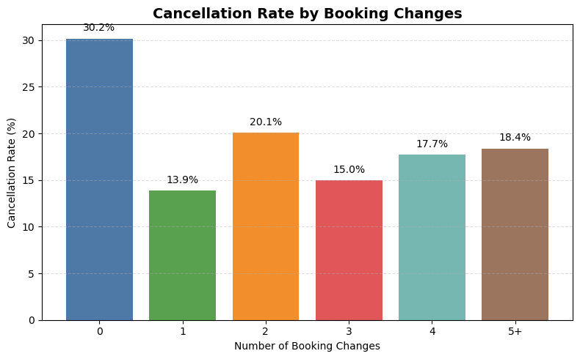

Key Observation:
- Bookings with no booking changes have the highest cancellation rate (30.2%), indicating that customers who never modify their reservations are more likely to cancel.
- A single booking change is associated with the lowest cancellation rate (13.9%), suggesting that customers who modify their bookings are generally more committed to their stay.
- Cancellation rates remain relatively stable for bookings with 2 or more changes, although these categories represent a much smaller share of total bookings.
- Overall, making at least one booking modification appears to reduce the likelihood of cancellation, indicating higher customer engagement and booking commitment.

- ADR Distribution by Cancellation Status:

plt.figure(figsize=(8,5))
box = plt.boxplot(
[
df[df["is_canceled"] == 0]["adr"],
df[df["is_canceled"] == 1]["adr"]
],
labels=["Not Canceled", "Canceled"],
patch_artist=True,
showfliers=False
)
colors = ["#4E79A7", "#E15759"]

for patch, color in zip(box["boxes"], colors):
patch.set_facecolor(color)

plt.title("ADR Distribution by Cancellation Status",fontsize=14, fontweight='bold')
plt.xlabel("Booking Status")
plt.ylabel("Average Daily Rate (ADR)")
plt.grid(axis="y", linestyle="--", alpha=0.4)
plt.tight_layout()
plt.show()
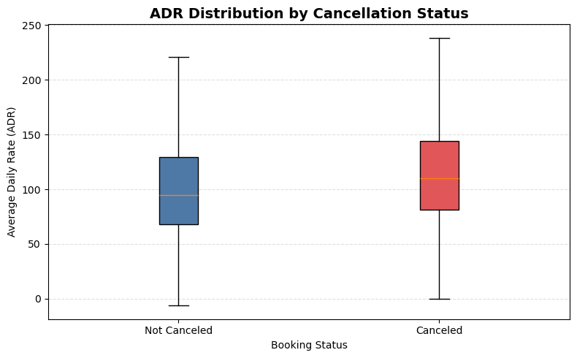

Key Observation:

- Cancelled bookings have a higher median ADR than bookings that were not cancelled, indicating that higher-priced reservations are more likely to be cancelled.
- The ADR distribution for cancelled bookings is shifted upward, suggesting that cancelled reservations generally involve more expensive room rates.
- Cancelled bookings also exhibit greater variability in ADR, indicating a wider range of room prices among cancelled reservations.
- Overall, the analysis suggests that higher-value bookings contribute more to potential revenue loss when cancellations occur, highlighting the importance of targeted cancellation management for premium-priced bookings.

Task 7: Actionable Insights: Providing recommendations based on the analysis to improve hotel operations and customer satisfaction.

Ans: Objective:
The objective of this task was to provide actionable recommendations based on the insights obtained from the exploratory data analysis. These recommendations aim to improve hotel operations, reduce booking cancellations, optimize revenue, and enhance overall customer satisfaction.

Actionable Insights & Recommendations:

- Deposit Policy Optimization
Insight:
Analysis showed that bookings with certain deposit types experienced significantly higher cancellation rates than others.
Recommendation:
Review and optimize deposit policies for high-risk bookings by introducing stricter deposit requirements or flexible cancellation terms to minimize revenue loss.

- Distribution Channel Management
Insight:
Cancellation rates varied across different distribution channels, indicating that some booking channels are more prone to cancellations.
Recommendation:
Strengthen partnerships with reliable distribution channels and review cancellation policies for channels with consistently higher cancellation rates.

- Improve Booking Management
Insight:
Bookings with modifications exhibited different cancellation behavior, suggesting that reservation changes may indicate booking uncertainty.
Recommendation:
Monitor bookings with multiple modifications and implement proactive follow-ups or confirmation reminders to reduce potential cancellations.

- Revenue Protection
Insight:
The Average Daily Rate (ADR) differed between cancelled and completed bookings, highlighting the potential revenue impact of cancellations.
Recommendation:
Identify high-value bookings that are at greater risk of cancellation and implement targeted retention strategies, such as personalized offers or flexible booking options.

- Seasonal Pricing Strategy
Insight:
Booking volume and ADR varied across different months, reflecting clear seasonal demand patterns.
Recommendation:
Adopt dynamic pricing strategies during peak seasons to maximize revenue while offering promotional pricing during low-demand periods to maintain occupancy.

- Hotel-Specific Marketing
Insight:
City Hotels and Resort Hotels attracted different customer segments and booking sources.
Recommendation:
Design separate marketing campaigns and promotional offers tailored to the customer profiles of each hotel type to improve customer acquisition and satisfaction.

- Customer Retention
Insight:
Transient customers formed the largest customer segment and contributed significantly to hotel bookings.
Recommendation:
Introduce loyalty programs, personalized discounts, and exclusive benefits to encourage repeat bookings and strengthen long-term customer relationships.

- Data-Driven Decision Making
Insight:
The analysis identified multiple factors influencing booking patterns, cancellations, and revenue performance.
Recommendation:
Leverage these insights to support data-driven decisions in pricing, inventory management, customer targeting, and operational planning, ultimately improving hotel efficiency and guest satisfaction.

Objectives:
- What is the average lead time for bookings that are cancelled versus those that are not cancelled?
Ans: Objective:
To compare the average lead time between cancelled and non-cancelled bookings and understand how advance booking behaviour relates to booking cancellations.
Methodology / Approach:
To answer this objective, the dataset was grouped based on the booking cancellation status (is_cancelled). The average lead time was then calculated for each group to compare how far in advance customers made their reservations.
The cancellation status was mapped to meaningful labels:
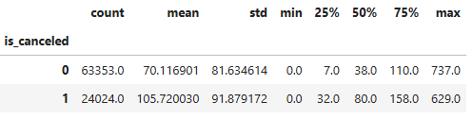
- 0 → Not Cancelled
- 1 → Cancelled

Visualization Selection:

Two visualizations were used to answer this objective:
- Box Plot: Used to examine the distribution of lead times, compare the spread between cancelled and non-cancelled bookings, and identify potential outliers before conducting the final comparison.
- Bar Chart: Used to compare the average lead time between cancelled and non-cancelled bookings, providing a clear and direct comparison that answers the objective.

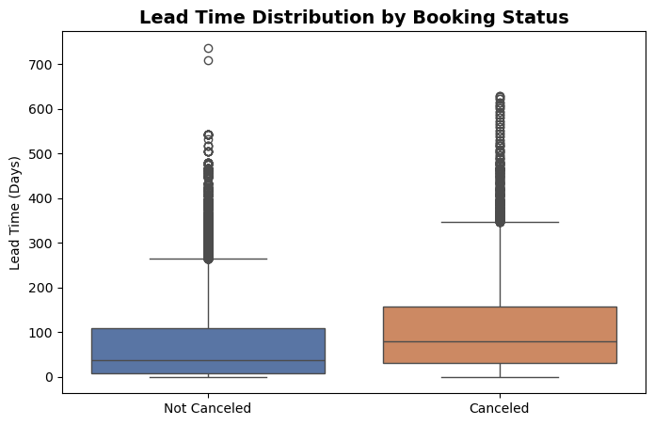
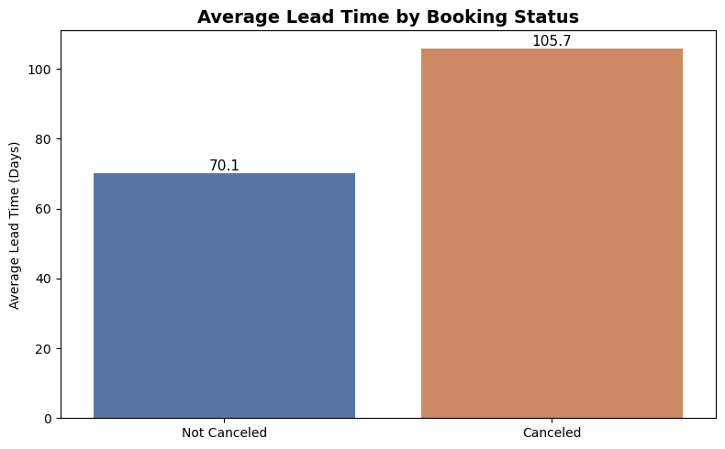
Key Findings:

- Cancelled bookings have an average lead time of 105.7 days, compared to 70.1 days for completed bookings.
- Customers making reservations further in advance are more likely to cancel.
- Longer lead times are associated with greater uncertainty in travel plans.
- Lead time is an important feature for predicting booking cancellations.

Recommendations:

- Monitor bookings with long lead times, as they have a higher probability of cancellation.
- Send reminder emails and personalized offers to customers with advance bookings to improve booking commitment.
- Review deposit and cancellation policies for reservations made well in advance.
- Incorporate lead time into predictive models to improve cancellation forecasting and revenue management.

- Which month has the highest number of bookings?
Ans: Objective:
To identify the month with the highest booking volume and understand seasonal booking patterns that can support demand forecasting and resource planning.

Methodology / Approach:
The dataset was grouped by the arrival month (arrival_date_month), and the total number of bookings was calculated for each month using the booking count. To improve readability, the months were arranged in calendar order (January to December) before visualization.

Visualization Selection:
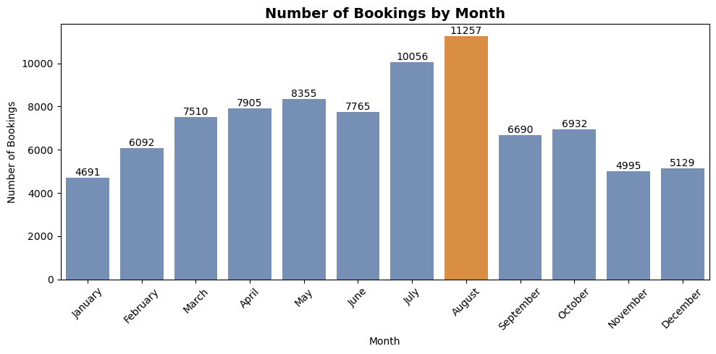
A bar chart was selected because the objective is to compare the number of bookings across multiple categorical groups (months). The chart clearly highlights differences in booking volume and makes it easy to identify peak and low-demand months.

Key Findings:
- August recorded the highest number of bookings (11,257), making it the peak booking month.
- Booking demand gradually increased from January to August, followed by a noticeable decline in the remaining months.
- July (10,056 bookings) and August experienced the highest booking activity, indicating a strong seasonal demand during the summer period.
- January recorded the lowest number of bookings (4,691), suggesting comparatively lower travel demand at the beginning of the year.

Recommendations:
- Increase staffing, room availability, and operational resources during July and August to efficiently manage peak booking demand.
- Implement dynamic pricing strategies during high-demand months to maximize revenue while maintaining occupancy.
- Introduce promotional offers and marketing campaigns during low-demand months, particularly January, November, and December, to improve occupancy.
- Use seasonal booking trends for demand forecasting and inventory planning to optimize hotel operations throughout the year.

- What is the distribution of ADR (Average Daily Rate) across different customer types?
Ans: Objective:
To compare the Average Daily Rate (ADR) across different customer types and identify which customer segments generate higher room revenue.

Methodology / Approach:
The dataset was grouped by customer type (customer_type), and the average ADR was calculated for each customer segment. The resulting averages were then sorted in descending order to facilitate comparison among customer types.

Visualization Selection:
A bar chart was used to compare the average ADR across different customer types. This visualization provides a clear comparison of revenue generated by each customer segment and makes it easy to identify the highest and lowest ADR values.
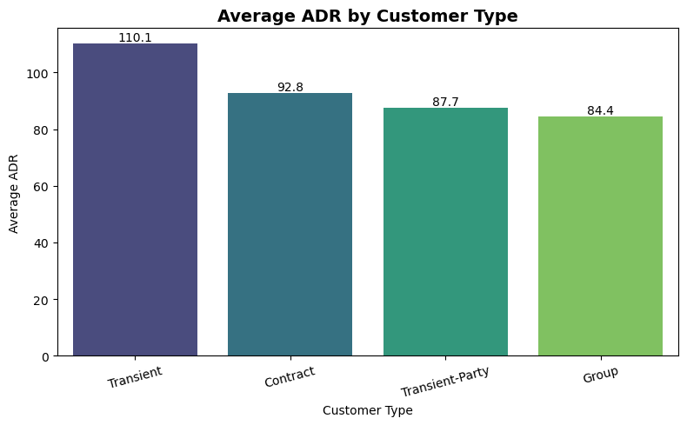
Key Findings:
- Transient customers generate the highest Average Daily Rate (110.1), making them the most valuable customer segment in terms of revenue per booking.
- Contract customers have the second-highest ADR (92.8), followed by Transient-Party (87.7) and Group (84.4) customers.
- Individual travellers (Transient) are willing to pay significantly higher room rates than customers booking under contracts or group reservations.
- Group bookings have the lowest ADR, indicating that hotels typically offer discounted rates for bulk or group reservations.

Recommendations:
- Prioritize Transient customers through targeted marketing campaigns and premium service offerings to maximize revenue.
- Develop personalized packages and loyalty programs for high-value customer segments to encourage repeat bookings.
- Periodically review pricing agreements for Contract and Group bookings to ensure discounted rates remain profitable.
- Design differentiated pricing strategies for each customer type to balance occupancy levels and revenue generation.

- How many bookings had special requests, and what is the average number of special requests per booking?
Ans: Objective:
To determine how many bookings included special requests and evaluate the average number of special requests per booking to better understand guest service requirements.

Methodology / Approach:
A flag was created to identify bookings with one or more special requests using the total_of_special_requests attribute. The total number of bookings with special requests and the average number of special requests per booking were calculated. Additionally, the distribution of bookings by the number of special requests (0–5) was analysed to understand guest request patterns.

Visualization Selection:
A bar chart was used to display the distribution of bookings by the number of special requests. This visualization clearly illustrates how frequently customers make special requests and highlights the proportion of bookings with no requests versus those with one or more requests.
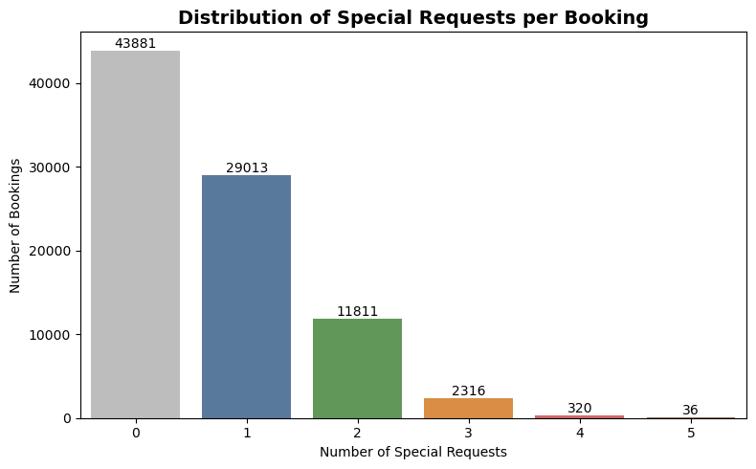

Key Findings:
- Out of 87,377 bookings, 43,496 (49.8%) included at least one special request, while 43,881 (50.2%) had no special requests.
- On average, customers made 0.70 special requests per booking, indicating that most bookings involved few or no additional requests.
- The majority of customers who made special requests requested only one special service (29,013 bookings), while bookings with multiple requests declined sharply.
- Bookings with four or five special requests were extremely rare, suggesting that extensive customization is uncommon among guests.

Recommendations:
- Ensure adequate operational resources to efficiently handle the high volume of bookings with one or two special requests.
- Analyse the most frequently requested services to optimize resource allocation and improve service efficiency.
- Offer personalized add-on services or premium packages for guests making special requests to enhance customer satisfaction and increase ancillary revenue.
- Regularly monitor special request trends to anticipate guest preferences and improve service planning.

- What is the cancellation rate for each market segment?
Ans: Objective:
To compare cancellation rates across different market segments and identify the customer segments that are more prone to booking cancellations.

Methodology / Approach:
The dataset was grouped by market segment (market_segment), and the cancellation rate for each segment was calculated as the percentage of cancelled bookings relative to the total bookings within that segment. The market segments were then sorted in descending order of cancellation rate to facilitate comparison.

Visualization Selection:
A horizontal bar chart was used to compare the cancellation rates across different market segments. This visualization provides a clear ranking of market segments based on their cancellation rates and makes it easy to identify segments with the highest and lowest cancellation risk.
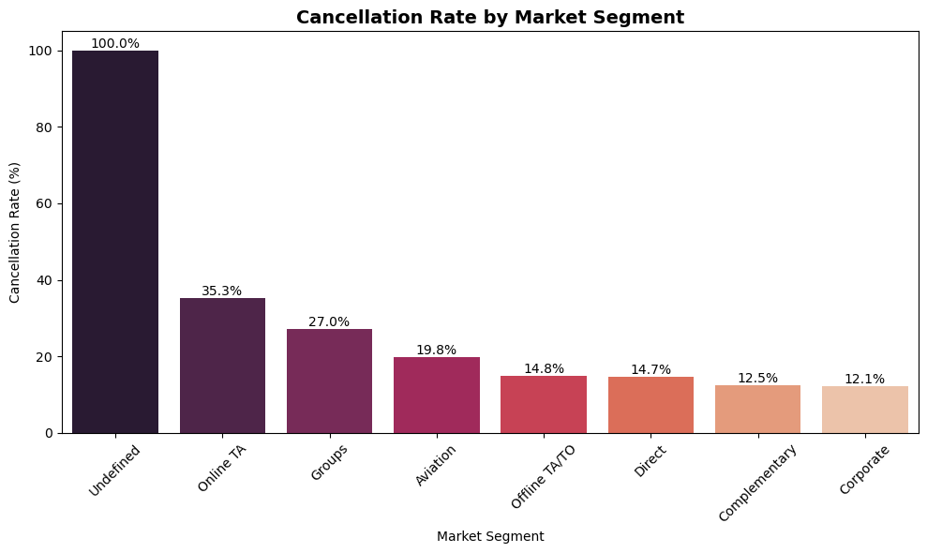
Key Findings:
- The Undefined market segment recorded the highest cancellation rate (100%); however, this result should be interpreted with caution due to the very small number of bookings.
- Among the major market segments, Online TA has the highest cancellation rate (35.3%), indicating that bookings made through online travel agencies are more likely to be cancelled.
- Groups (27.0%) and Aviation (19.8%) also exhibit relatively high cancellation rates compared to other customer segments.
- Corporate (12.1%), Complementary (12.5%), and Direct (14.7%) bookings have the lowest cancellation rates, making them the most reliable customer segments.
- Since Online TA contributes a high booking volume while also having the highest cancellation rate among major segments, improving cancellation management for this segment could significantly reduce revenue loss.

Recommendations:
- Implement targeted retention strategies for Online TA bookings, such as booking reminders, flexible modification options, or loyalty incentives, to reduce cancellations.
- Review booking policies and contract terms for Group and Aviation segments to identify factors contributing to their relatively high cancellation rates.
- Strengthen relationships with Corporate and Direct customers through exclusive offers and loyalty programs, as these segments demonstrate the lowest cancellation rates.
- Investigate the Undefined market segment to improve data quality and ensure bookings are correctly classified for more reliable analysis and decision-making.

- Which distribution channel has the highest average ADR?
Ans: Objective:
To compare the Average Daily Rate (ADR) across different distribution channels and identify which booking channel generates the highest room revenue.

Methodology / Approach:
The dataset was grouped by distribution channel (distribution_channel), and the average ADR was calculated for each channel. The resulting averages were sorted in descending order to facilitate comparison and identify the highest-performing distribution channel.

Visualization Selection:
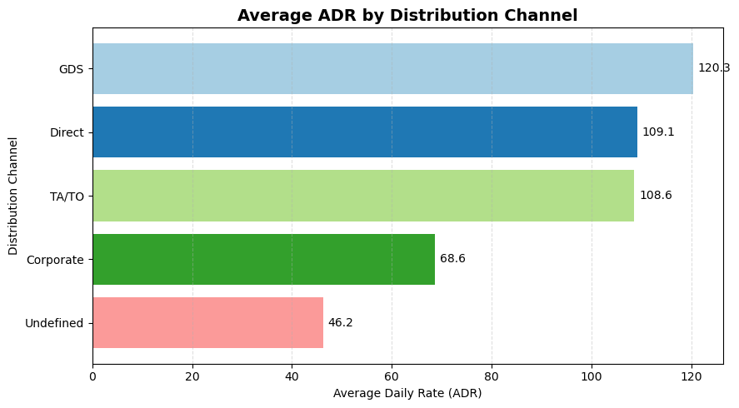
A bar chart was used to compare the average ADR across different distribution channels. This visualization clearly highlights the revenue generated by each booking channel and makes it easy to identify the channels contributing the highest and lowest average room rates.
Key Findings:
- GDS recorded the highest Average Daily Rate (120.3), making it the most premium distribution channel.
- Direct (109.1) and TA/TO (108.6) channels also generated relatively high ADRs, indicating strong revenue potential from these booking sources.
- Corporate bookings had a considerably lower average ADR (68.6) compared to GDS, Direct, and TA/TO channels.
- The Undefined distribution channel recorded the lowest ADR (46.2), suggesting either heavily discounted bookings or possible data quality issues.
- The variation in ADR across distribution channels highlights the importance of channel-specific pricing and distribution strategies.

Recommendations:
- Prioritize GDS as a premium sales channel by maintaining competitive room availability and targeted marketing for high-value travellers.
- Encourage more Direct bookings through loyalty programs, exclusive discounts, and value-added benefits to reduce third-party dependency while maintaining high ADR.
- Periodically review pricing agreements with corporate clients to ensure negotiated rates remain profitable.
- Investigate the Undefined distribution channel to improve data quality and ensure bookings are correctly classified for more accurate revenue analysis.

- What is the correlation between lead time and the length of stay?
Ans: Objective:
To examine the relationship between lead time and the total length of stay, and determine whether customers who book further in advance tend to stay for longer durations.

Methodology / Approach:
A new feature, total_stay, was created by combining weekend nights and week nights to represent the total length of stay for each booking. The Pearson correlation coefficient was then calculated to measure the strength and direction of the relationship between lead time and total length of stay. Finally, a scatter plot with a regression line was used to visualize the relationship.

Visualization Selection:
Two scatter plots were used to analyse this objective:
- Scatter Plot: Used to visualize the relationship between lead time and total length of stay, helping identify the distribution, spread, and overall pattern of the data.
- Scatter Plot with Regression Line: Used to illustrate the overall trend and direction of the relationship. The regression line, along with the Pearson correlation coefficient (r = 0.318), provides a clearer understanding of the strength of the correlation between the two variables.
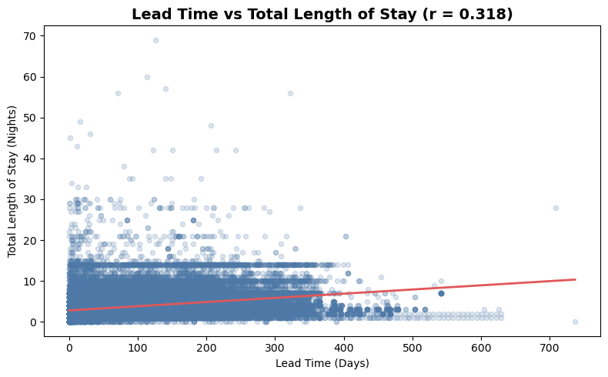
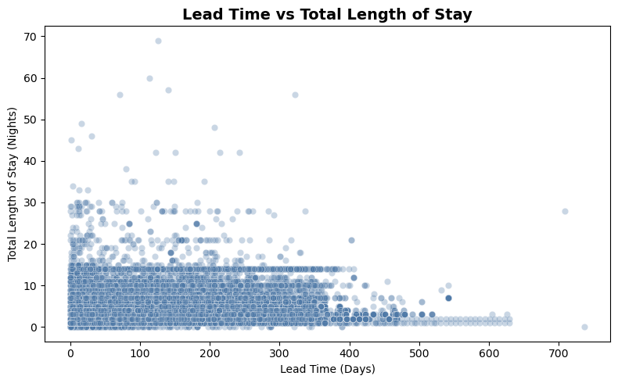
Key Findings:
- The Pearson correlation coefficient is 0.318, indicating a weak positive correlation between lead time and total length of stay.
- Customers who book further in advance tend to stay slightly longer; however, the relationship is not strong.
- Most bookings are concentrated within 0–15 nights, regardless of the lead time, indicating that short stays dominate across all booking windows.
- A small number of bookings involve exceptionally long stays and very early reservations, but these are relatively uncommon and do not significantly influence the overall trend.

Recommendations:
- Avoid relying solely on lead time to predict the length of stay, as the relationship is relatively weak.
- Incorporate additional factors such as customer type, market segment, hotel type, and distribution channel when forecasting guest stay duration.
- Design targeted promotions for customers who book well in advance, as they show a slight tendency toward longer stays and may contribute to higher overall revenue.
- Monitor long-stay bookings separately to better understand the factors influencing extended reservations and optimize room allocation strategies.

- How many bookings include children and/or babies?
Ans: Objective:
To determine the number of bookings that include children and/or babies and assess the proportion of family bookings compared to adult-only bookings.

Methodology / Approach:
A booking was classified as a family booking if it included one or more children and/or babies (children > 0 or babies > 0). The total number of family bookings and non-family bookings was then calculated to compare their distribution.

Visualization Selection:
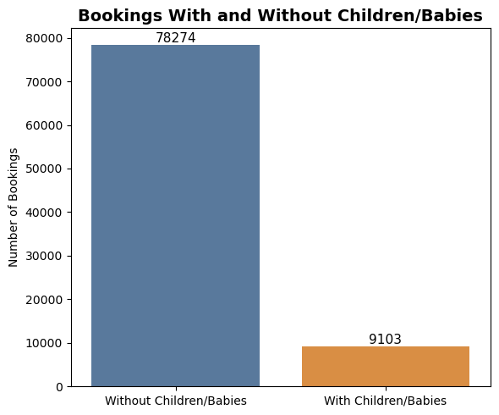
A bar chart was used to compare the number of bookings with and without children and/or babies. This visualization provides a clear comparison between family and non-family bookings, making it easy to understand the composition of the hotel's customer base.

Key Findings:
- Out of 87,377 bookings, 9,103 (10.4%) included children and/or babies, while 78,274 (89.6%) were made without children or babies.
- The majority of hotel bookings are from adult-only travellers, indicating that couples, solo travellers, and business guests form the primary customer base.
- Family bookings represent a relatively small but important customer segment, accounting for approximately one in every ten bookings.
- The lower proportion of family bookings suggests an opportunity to attract more family travellers through targeted offerings and promotions.

Recommendations:
- Introduce family-oriented packages and seasonal promotions to attract more guests traveling with children and babies.
- Enhance family-friendly amenities such as children's play areas, baby cots, extra beds, and kid-friendly dining options to improve the guest experience.
- Launch targeted marketing campaigns during school holidays and festive seasons when family travel demand is typically highest.
- Analyse the booking behaviour and spending patterns of family travellers to develop personalized offers and maximize revenue from this customer segment.

- What is the average lead time for repeated guests compared to new guests?
Ans: Objective:
To compare the average lead time between new guests and repeated guests, and understand how guest loyalty influences booking behaviour.

Methodology / Approach:
The dataset was grouped based on the guest type (is_repeated_guest), and the average lead time was calculated for each group. The binary values were then mapped to meaningful labels (New Guest and Repeated Guest) to facilitate comparison.
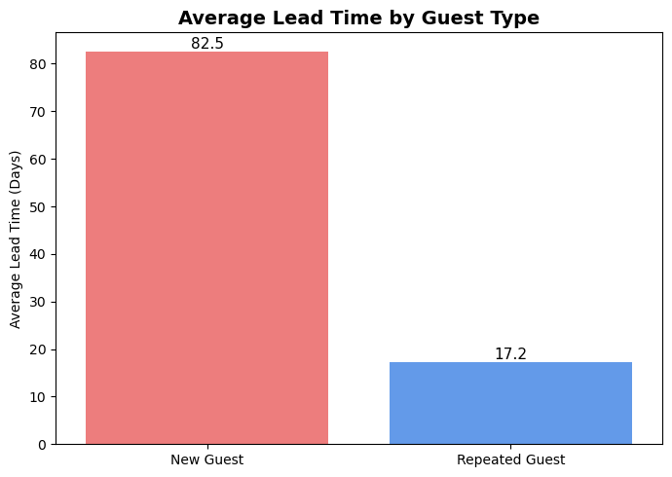
Visualization Selection:
A bar chart was used to compare the average lead time between new and repeated guests. This visualization provides a clear side-by-side comparison, making it easy to identify differences in booking behaviour between first-time and returning customers.

Key Findings:
- New guests have a significantly higher average lead time (82.5 days) compared to repeated guests (17.2 days).
- Repeated guests tend to book much closer to their arrival date, indicating greater familiarity and confidence in the hotel.
- The substantial difference in lead time suggests that new customers spend more time planning their trips, while loyal guests make more spontaneous or last-minute bookings.
- Guest loyalty appears to influence booking behaviour, with repeated guests requiring considerably less advance planning than first-time visitors.

Recommendations:
- Encourage new guests to book earlier through early-bird discounts and advance booking promotions to secure future occupancy.
- Offer exclusive last-minute deals and personalized offers to repeated guests, as they are more likely to make bookings closer to their stay dates.
- Strengthen loyalty programs to increase the number of repeated guests, who demonstrate predictable booking behaviour and may require lower marketing efforts.
- Segment marketing campaigns based on guest type, using advance-planning promotions for new customers and personalized retention campaigns for returning guests.

- What is the most common combination of reserved room type and assigned room type?
Ans: Objective:
To identify the most frequent combination of reserved room type and assigned room type, and evaluate how effectively the hotel allocates rooms according to customer reservations.

Methodology / Approach:
A cross-tabulation (contingency table) was created using the reserved room type and assigned room type to calculate the frequency of each room allocation combination. This allowed the identification of the most common reserved–assigned room type pairs and helped assess the consistency of room assignments.

Visualization Selection:
A heatmap was used to visualize the frequency of combinations between reserved room types and assigned room types. This visualization effectively displays two categorical variables simultaneously, making it easy to identify the most common room allocation combinations and detect patterns of room reassignment.

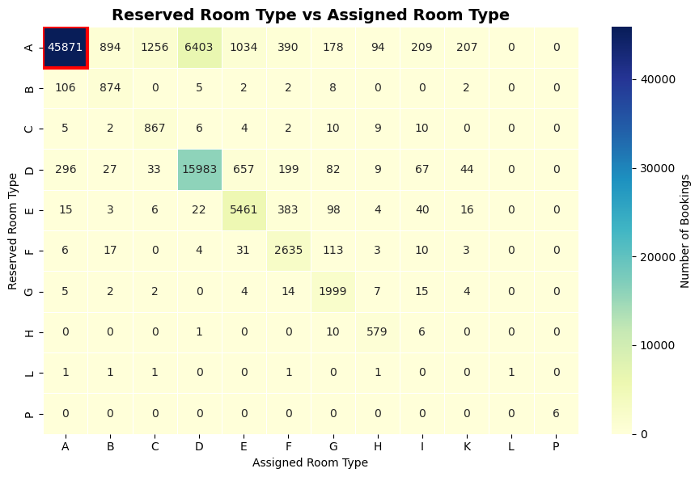
Key Findings:
- The most common room allocation is Reserved Room Type A → Assigned Room Type A, with 45,871 bookings, indicating that most guests receive the room type they originally reserved.
- Most bookings are concentrated along the diagonal of the heatmap, suggesting that hotels generally assign guests to their reserved room types.
- A notable exception is Reserved Room Type A → Assigned Room Type D (6,403 bookings), indicating that Room Type A bookings are frequently upgraded or reassigned to Room Type D.
- Reassignments among other room types are relatively infrequent, demonstrating efficient room allocation and effective inventory management.

Recommendations:
- Maintain the current room allocation strategy to ensure guests continue receiving their reserved room types, thereby enhancing customer satisfaction.
- Investigate the frequent reassignment from Room Type A to Room Type D to determine whether it is driven by overbooking, inventory constraints, or complimentary upgrades.
- Improve room inventory planning during peak demand periods to minimize unnecessary room reassignments.
- Utilize strategic room upgrades to enhance guest experience while ensuring operational efficiency and revenue optimization.

Subjectives:

- How does the lead time affect the likelihood of booking cancellations?

Ans: Objective:
To examine how the time between booking and arrival (lead time) influences the likelihood of booking cancellations and identify booking windows associated with higher cancellation risk.

Methodology / Approach:
- Grouped bookings into six lead-time intervals (0–30, 31–60, 61–90, 91–180, 181–365, and 365+ days).
- Calculated the cancellation rate for each lead-time bucket.
- Visualized the trend using a line chart to evaluate how cancellation likelihood changes as lead time increases.

Visualization Selection:
A line chart is the most appropriate choice because lead time is an ordered variable. It clearly illustrates the trend in cancellation rates across increasing booking horizons, making it easy to identify how cancellation risk changes as customers book further in advance.
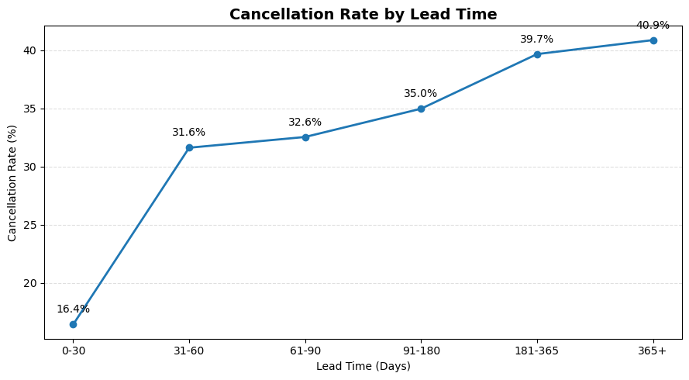

Insights:
- Customers who book further in advance are progressively more likely to cancel, indicating that long-term reservations are less certain than short-term bookings.
- The sharp increase in cancellation rates after the first 30 days suggests that travel plans become more susceptible to changes as the booking horizon extends.
- Very early bookings (more than six months in advance) represent the highest cancellation risk and should be monitored more closely.
- Lead time is an effective indicator for identifying potentially unstable reservations and can support more accurate demand forecasting and revenue management.
- Segmenting bookings based on lead time enables hotels to apply targeted reservation policies instead of using a uniform cancellation strategy for all guests.
Recommendations:
- Implement stricter deposit or cancellation policies for bookings with longer lead times to reduce cancellation risk.
- Send automated confirmation and reminder emails to guests with advance bookings to encourage commitment and reduce last-minute cancellations.
- Incorporate lead time into predictive cancellation models to identify high-risk reservations early.
- Apply data-driven overbooking strategies during peak periods by considering historical cancellation rates across different lead-time segments.

- What impact do special requests have on booking cancellations?
Ans: Objective:
To analyse how the number of special requests made by guests influences booking cancellation behaviour and determine whether special requests can serve as an indicator of customer booking commitment.

Methodology / Approach:
- Grouped bookings based on the number of special requests made by guests.
- Calculated the cancellation rate for each special request category.
- Used a bar chart to compare cancellation rates across different numbers of special requests.
- Evaluated the relationship between guest engagement (through special requests) and booking cancellation behaviour.

Visualization Selection:
A bar chart was selected because the number of special requests is a discrete categorical variable. It enables clear comparison of cancellation rates across each request category, making it easy to identify patterns and differences in customer behaviour.
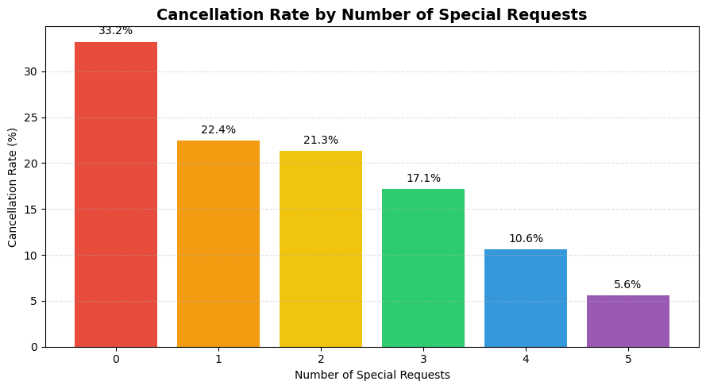
Insights:
- Guests who make more special requests are generally more committed to their reservations, resulting in significantly lower cancellation rates.
- The steady decline in cancellation rates with increasing special requests suggests that customer engagement is a strong indicator of booking reliability.
- Bookings with no special requests exhibit the highest cancellation risk, indicating a lower level of customer commitment or planning.
- Special requests can be incorporated into cancellation risk assessment models, allowing hotels to distinguish between high-risk and low-risk reservations more effectively.
- Understanding guest engagement through special requests enables hotels to implement more personalized booking management and customer retention strategies.

Recommendations:
- Prioritize reservations with multiple special requests, as these guests are more likely to honour their bookings.
- Use bookings without special requests as an early indicator of higher cancellation risk and consider sending reminder or reconfirmation messages before arrival.
- Incorporate the number of special requests into predictive cancellation models to improve forecasting accuracy.
- Encourage guests to share their preferences during the booking process, as greater engagement may strengthen booking commitment and improve customer satisfaction.

- What trends can be observed in the booking behaviour of international guests compared to domestic guests?

Ans: Objective:
To compare the booking behaviour of domestic and international guests by analysing their booking volume and average length of stay, thereby identifying differences that can support customer segmentation and operational planning.

Methodology / Approach:
- Created a new guest_type feature by classifying guests as Domestic (country = 'PRT') and International (all other countries) based on their country of origin.
- Created a total_stay feature by summing stays_in_weekend_nights and stays_in_week_nights to calculate the total duration of each guest's stay.
- Compared the booking volume between domestic and international guests to understand the distribution of the customer base.
- Calculated the average length of stay for each guest group to identify differences in booking behaviour.
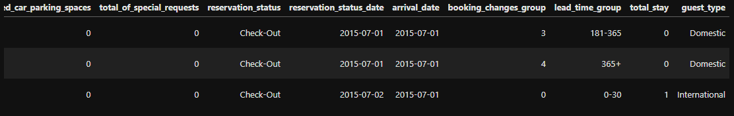
- Used comparative visualizations to evaluate how guest origin influences booking patterns.
Visualization Selection:
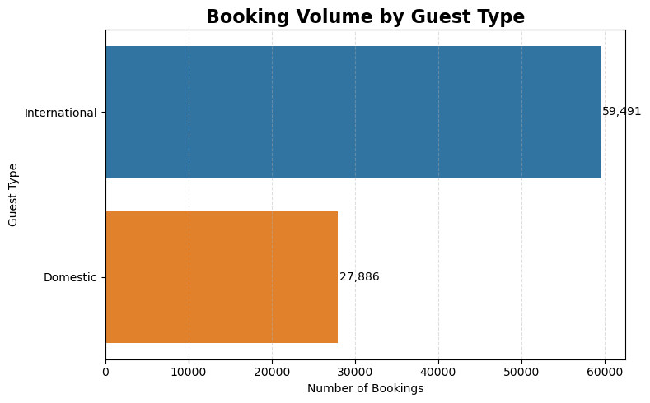
- Horizontal Bar Chart: Used to compare the booking volume of domestic and international guests, allowing for an easy comparison between the two customer segments.

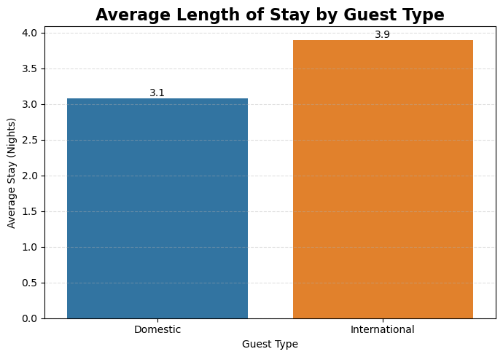
- Bar Chart: Used to compare the average length of stay of domestic and international guests, highlighting differences in booking patterns and accommodation usage.

Insights:
- International guests represent the hotel's primary customer segment, making international tourism a key driver of overall occupancy.
- Despite making fewer bookings, domestic guests tend to have shorter stays, indicating different travel purposes and booking patterns compared to international visitors.
- The longer stays of international guests suggest greater revenue potential per reservation and emphasize the importance of retaining this customer segment.
- The contrasting booking behaviours indicate that domestic and international guests have different accommodation needs, requiring tailored marketing strategies and service offerings.
- Understanding these behavioural differences enables hotels to optimize pricing, promotional campaigns, and resource allocation for each customer segment.

Recommendations:
- Develop targeted marketing campaigns for international travellers, as they contribute the majority of bookings and tend to stay longer.
- Introduce attractive weekend and short-stay packages for domestic guests to encourage longer visits and increase occupancy.
- Design personalized service packages for international guests, such as airport transfers, multilingual assistance, or local travel experiences, to enhance guest satisfaction.
- Use guest origin as a segmentation variable in revenue management and demand forecasting to improve pricing strategies and operational planning.

- What is the impact of the day of the week on booking cancellations?

Ans: Objective:
To analyse how the day of arrival influences booking cancellation rates and identify weekly patterns that can help hotels optimize reservation management and operational planning.

Methodology / Approach:
- Extracted the day of the week from the existing arrival_date column.
- Calculated the cancellation rate for each day of arrival by averaging the is_cancelled values.
- Ordered the weekdays chronologically from Monday to Sunday to ensure meaningful trend analysis.
- Visualized the cancellation rates across the week to identify variations in guest cancellation behaviour.

Visualization Selection:
A line chart was selected because the days of the week follow a natural chronological order. It effectively highlights trends and fluctuations in cancellation rates, making it easier to identify peak and low cancellation periods throughout the week.
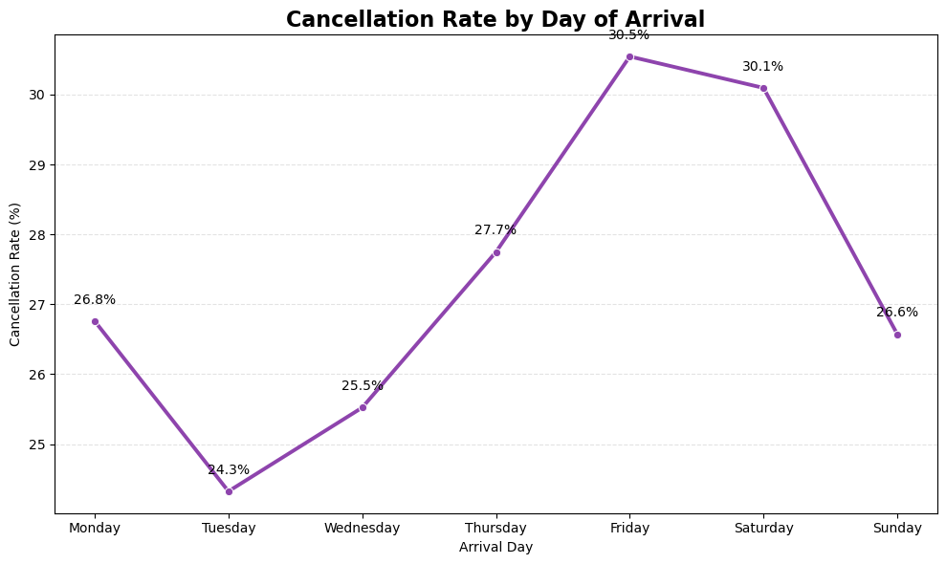

Insights:
- Friday records the highest cancellation rate (30.5%), followed closely by Saturday (30.1%), indicating that bookings scheduled for the beginning of the weekend are more likely to be cancelled than those on other days.
- Tuesday has the lowest cancellation rate (24.3%), while Wednesday (25.5%) also shows relatively low cancellation levels, suggesting that midweek arrivals are generally associated with more reliable bookings.
- Cancellation rates gradually increase from Tuesday (24.3%) to Friday (30.5%), reflecting a steady rise of over 6 percentage points as the weekend approaches.
- After peaking on Friday, the cancellation rate declines to 26.6% on Sunday, indicating that the elevated cancellation risk is concentrated around the start of the weekend rather than remaining consistently high throughout it.
- The observed weekly pattern suggests that guest travel behaviour varies by arrival day, with weekend-oriented bookings exhibiting greater uncertainty than midweek reservations.

Recommendations:
- Review cancellation and deposit policies for Friday and Saturday arrivals, as these days consistently experience the highest cancellation rates.
- Increase monitoring and reconfirmation efforts for reservations scheduled at the end of the week to reduce last-minute cancellations.
- Use weekday-specific cancellation patterns when forecasting occupancy and planning controlled overbooking strategies.
- Promote targeted offers for Tuesday to Thursday arrivals, where bookings demonstrate comparatively lower cancellation risk, to improve occupancy during more stable periods.

- What are the most common countries for international guests, and how do their booking patterns compare to domestic guests?

Ans: Objective:

To identify the most common international guest countries and compare their booking behaviour with domestic guests in terms of booking volume and advance booking patterns.

Methodology / Approach:

- Filtered the dataset to exclude Portugal (PRT) and identified the Top 10 international countries based on booking volume.
- Selected the Top 5 international countries with the highest number of bookings for behavioural comparison.
- Compared the average lead time of the selected international countries with domestic guests (Portugal).
- Used comparative visualizations to evaluate both the contribution of international markets and differences in booking behaviour.

Visualization Selection:

- A horizontal bar chart was used to rank the top international guest countries because it provides a clear comparison when category names are relatively long.
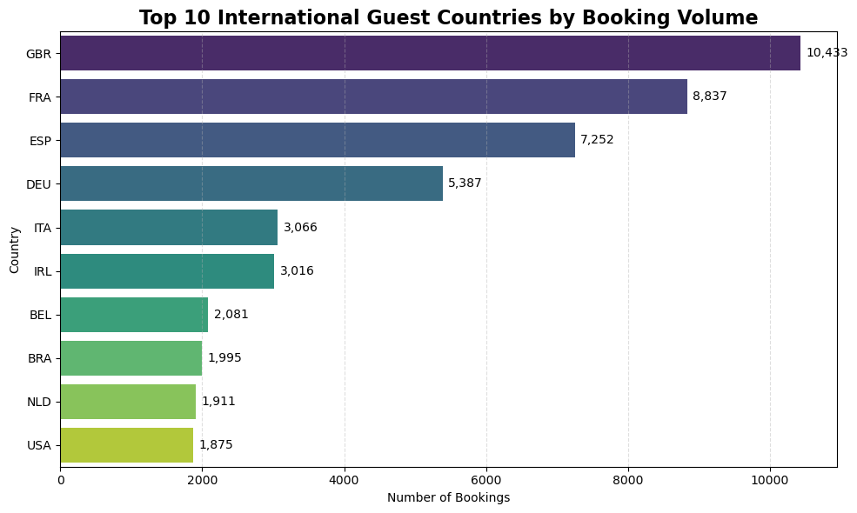

- A bar chart was selected to compare the average lead time across domestic guests and the top international markets, making differences in booking behaviour easy to interpret.
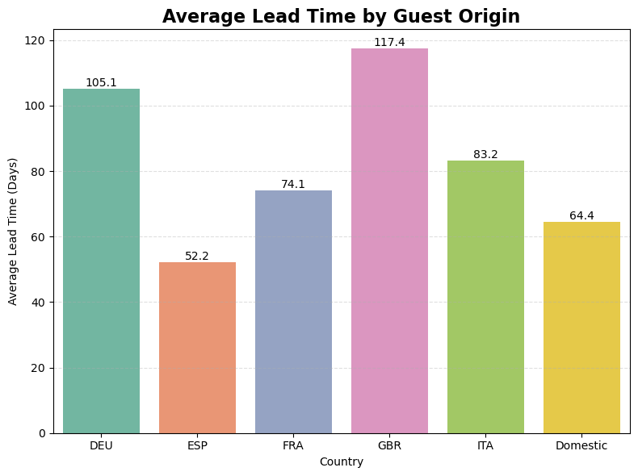
Insights:
- Great Britain contributes the highest number of international bookings (10,433), followed by France (8,837) and Spain (7,252), indicating that the hotel's international demand is heavily concentrated in a few key European markets.
- Guests from Great Britain book an average of 117.4 days in advance, nearly 53 days earlier than domestic guests (64.4 days), demonstrating a much longer travel planning horizon.
- While most major international markets—including Germany (105.1 days), Italy (83.2 days), and France (74.1 days)—book significantly earlier than domestic guests, Spanish guests (52.2 days) tend to make reservations closer to their arrival dates.
- The variation in booking lead times across countries highlights that international guests do not exhibit uniform booking behaviour, emphasizing the importance of market-specific demand forecasting and reservation strategies.
- Since the largest international markets also tend to book well in advance, these guests provide hotels with greater visibility into future occupancy, enabling more effective pricing and inventory management.

Recommendations:
- Prioritize marketing efforts in Great Britain, France, and Spain, as these markets generate the highest volume of international bookings.
- Develop country-specific promotional campaigns and pricing strategies based on observed booking lead times instead of applying a uniform approach to all international guests.
- Encourage early bookings in markets with shorter planning horizons, such as Spain, through advance booking discounts and promotional offers.
- Use country-level booking behaviour to improve occupancy forecasting, revenue management, and targeted customer engagement strategies across different international markets.

